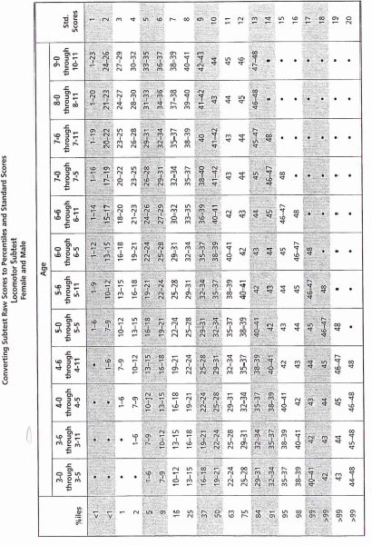
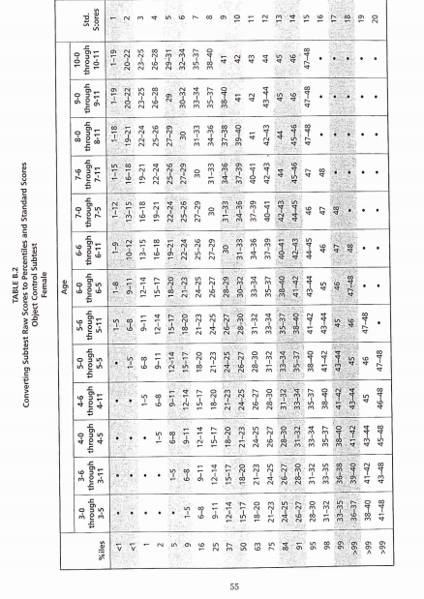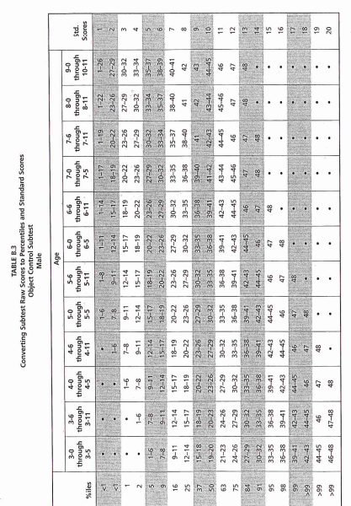
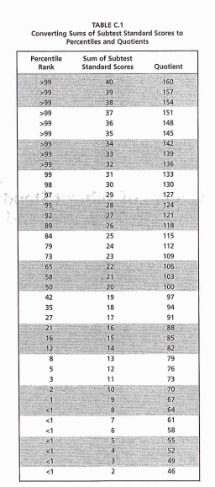

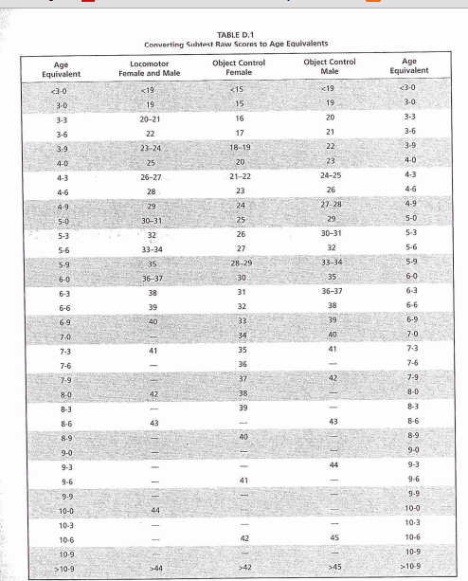

Descriptive Ratings of Scores
Descriptive rating GMQ standard score Percentile score
Very Superior >130 99th
Superior 121-130 92-98th
Above Average 111-120 76-91st
Average 90-110 25-75th
Below average 80-89 10-24th
Poor 70-79 2-8th
Very poor <70 <1st

